

**KB6003 Vehicle Aerodynamics**

**Tutorial 2**

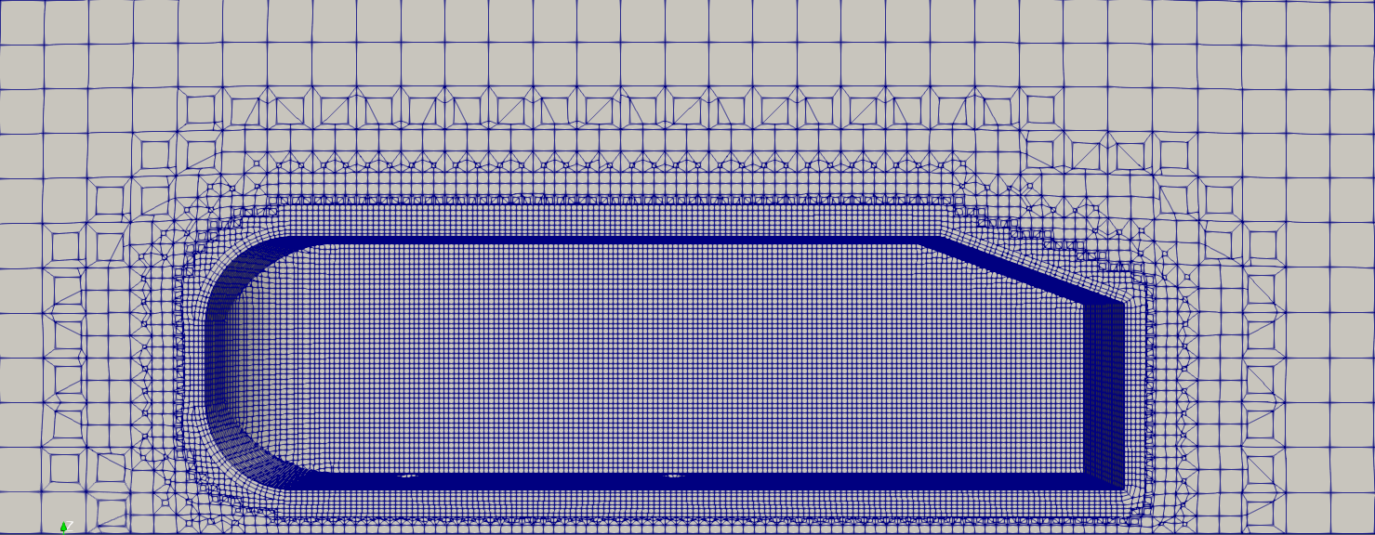

**Ahmed Body Meshing**

**Date: 8th October 2018**

Contents

Table of Figures 2

Table of Tables 3

1 Introduction 4

2 Refining Geometries 4

2.1 Reference Zone for Mesh 4

2.1.1 Creating Reference Extrudes for Outer Walls and Coarse Mesh. 4

2.1.2 Creating Reference Extrudes for Fine Mesh 6

2.2 Splitting the Ahmed Body 7

2.3 Creating STL files for Meshing 8

2.4 Creating refinement areas from ParaView (paraFoam) 9

2.4.1 Making the VTK File Compatible with “surfaceFeatureConvert” 13

3 OpenFOAM Initial Case Setup 15

3.1 Copying Tutorial Cases and Preparing 15

3.2 Modifying Dictionaries 17

3.2.1 surfaceFeaturesDict / surfaceFeatureExtract (surfaceFeaturesExtractDict) 17

3.2.2 blockMesh (blockMeshDict) 19

3.2.3 snappyHexMeshDict 21

3.2.4 meshQuality (meshQualityDict) 25

3.2.5 decomposePar (decomposeParDict) 26

3.3 Mesh Generation 26

3.4 Checking the Generated Mesh 28

3.4.1 Using checkMesh Command 28

3.4.2 Using ParaView 29

3.5 Recompiling the Mesh 31

Appendix A: Co-Ordinates from Onshape 32

Appendix B: STL Exports 32

Appendix C: Vertices of a the Geometry 33

Appendix D: Single Run vs 2 Runs (snappyHexMesh) 33

Appendix E: Refinement Levels 35

Table of Figures

Figure 2.1: Using variables to dimension the rectangle. 5

Figure 2.2: Editing appearances of parts. 5

Figure 2.3: Enclosed Ahmed body. 6

Figure 2.4: Dimensions for the fine mesh reference. 6

Figure 2.5: Ahmed body with reference extrudes. 6

Figure 2.6: Creating a new plane from fillet edge. 7

Figure 2.7: Splitting the front of the Ahmed body. 8

Figure 2.8: Creating a new plane by offsetting "Top" plane. 8

Figure 2.9: ParaView 9

Figure 2.10: Import the ahmed_body.stl file to ParaView. 10

Figure 2.11: Camera controls toolbar. 10

Figure 2.12: Extract feature edges from the Ahmed body. 11

Figure 2.13: Change "Feature Angle" to show edge. 11

Figure 2.14: Selecting the edge for extraction. 12

Figure 2.15: Extracting the edge using the "Extract Selection" tool. 12

Figure 2.16: Save edge as a .vtk file. 13

Figure 2.17: Removing additional information from the VTK file. 14

Figure 3.1: OpenFOAM dictionary header. 17

Figure 3.2: Delete the contents of the body (highlighted). 18

Figure 3.3: Castellated mesh 22

Figure 3.4: Snapping phase. 22

Figure 3.5: Adding layers to mesh 23

Figure 3.6: Meshing process for this case. 27

Figure 3.7: Output from "checkMesh". 29

Figure 3.8: ParaView with mesh. 30

Figure 3.9: "Clip" in "Common" toolbar. 30

Figure 3.10: Representations toolbar. 30

Figure 3.11: "VCR Controls" and "Current Time Controls". 31

Table of Tables

Table 2.1: Variables for reference mesh wall dimensions. 4

Table 2.2: Parts to export 9

Table 3.1: OpenFOAM case folder structure. 15

Table 3.2: Patch types used in this tutorial <reference>. 21

Table 3.3: Changes to "snappyHexMeshDict" dictionary. 23

Table 3.4: Changes to "meshQualityDict" dictionary. 25

Table 3.5: Changes to "decomposeParDict" dictionary. 26

Table 3.6: Changes for “Run 2” 28

# Introduction

This tutorial will looks into generating a refined mesh in OpenFOAM using the snappyHexMesh tool. This is an introductive guide and more information can be found at [https://cfd.direct/openfoam/user-guide/v6-snappyhexmesh/.](https://cfd.direct/openfoam/user-guide/v6-snappyhexmesh/)

# Refining Geometries

## Reference Zone for Mesh

It is advisable to make “reference extrudes” (models/parts) for walls of different mesh areas (such as coarse and fine meshes). These allow easy differentiation of mesh zones using OpenFOAM and obtain co-ordinates (Appendix A) from geometry as well.

### Creating Reference Extrudes for Outer Walls and Coarse Mesh.

1. On the model, create 5 new variables as shown in step 9 of section 2.2 in tutorial 1, but with the parameters shown in table 2.1.

Table 2.1: Variables for reference mesh wall dimensions.

|  |  |  |  |  |  |
| --- | --- | --- | --- | --- | --- |
| Name | Value | Name | Value | Name | Value |
| box_x | 1000 | box_z | 2000 | back | 5 |
| box_y | 4000 | front | 3 |  | |

Note: Make sure these variables are above the features that they are to be used on in the “Features” tree.

1. Create a sketch on the “Top” plane as shown in steps 15 of section 2.2 in tutorial 1.
2. Sketch a rectangle to enclose the Ahmed body using the “Corner Rectangle” tool as shown in step 6 of section 2.2 in tutorial 1.
3. You can dimension the square using the variables created in step 1 of this section. The “box_x” variable can be multiplied by the “front” and “back” variable to get dimensions of front and back of the enclosure box from the “Origin”. The figure 2.1 below shows shows the completed sketch.

Note: All dimensions are from the “Origin”.

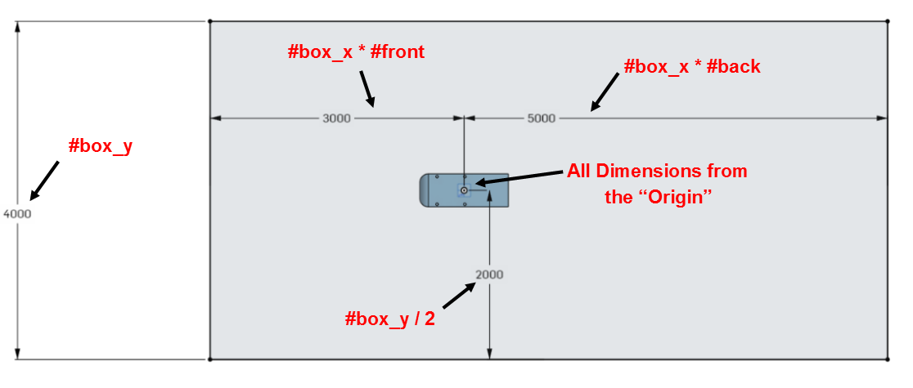

Figure 2.1: Using variables to dimension the rectangle.

1. Extrude the sketch as shown in step 8 of section 2.2 in tutorial 1 with “Blind” selected from the drop down menu. Input “#box_z” (without quotations) for the depth.

Note: Make sure the “New” tab is selected instead of the “Add” as the extrude should be a new part.

1. The new part (“Part 2”) will be opaque but can be made transparent by right clicking on the “Parts” list below “Features” list and clicking “Edit appearance”. Move the transparency slider to your liking (as shown in figure 2.2) and click ok.

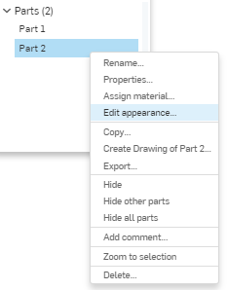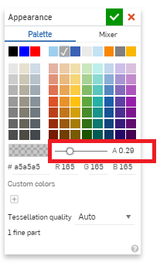

Figure 2.2: Editing appearances of parts.

1. The model should now look similar to figure 2.3 shown below.

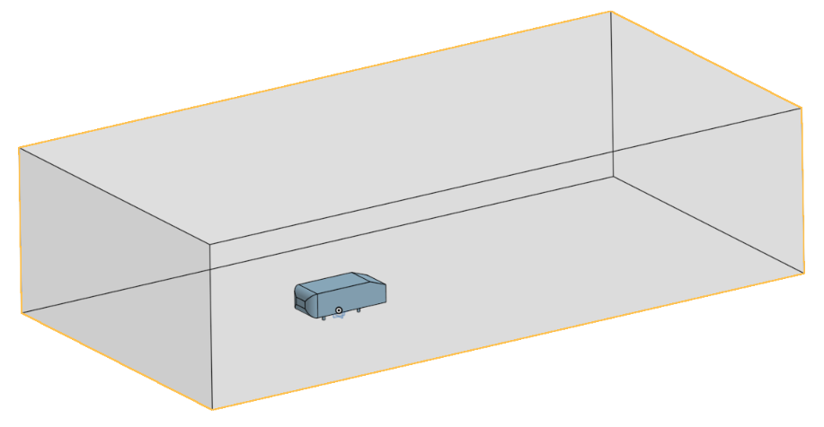

Figure 2.3: Enclosed Ahmed body.

### Creating Reference Extrudes for Fine Mesh

Follow from step 2 in section 2.3.1 but with the following fixed dimensions shown in figure 2.4 extruded to a height (z-axis) of 1000 mm. Alternatively, you can create/use variables and assign them to the sketch as well. The finished model should look similar to figure 2.5 shown below.

|  |
| --- |
| Figure 2.4: Dimensions for the fine mesh reference. |
| Figure 2.5: Ahmed body with reference extrudes. |

## Splitting the Ahmed Body

This section will look at splitting the Ahmed body into three parts; the front, back and the supports. This will be done on Onshape as shown in steps below. These steps will assume that you have completed the first tutorial and hence skip certain detailed explanations.

1. Open the previous (Tutorial 1) Ahmed body model on Onshape.
2. Use the “Parts” tree to make only the Ahmed body visible.
3. Using the “Plane” tool () and select the “Edge of Fillet” as the “Entities” as shown in figure 2.6. Then select “Line Angle” from the dropdown with the “Angle” value as 90 deg. and click ok (). This will create a plane between the filleted front and the back of the Ahmed body.

Note: There are multiple ways of creating a new plane. Feel free to use a method of your preference.

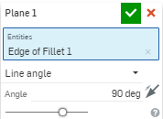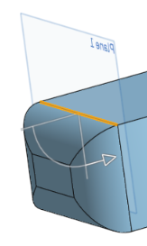

Figure 2.6: Creating a new plane from fillet edge.

1. Click on the “Split” tool () and make sure the part name corresponding to the Ahmed body is selected under the “Parts or surfaces to split” as shown in figure 2.7. If not, please click on the Ahmed body or select it from the parts tree.
2. Click on the “Entity to split with” and select the new plane as shown in figure 2.7 and click ok () to split. This will split the Ahmed body into 2 parts along the fillet edges which can be seen in the parts tree.

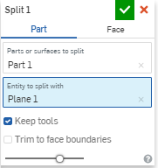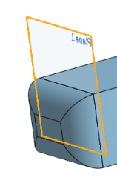

Figure 2.7: Splitting the front of the Ahmed body.

1. Similarly to step 3, create a new plane but with “Top” plane as the “Entities” with the “Offset” selected from the dropdown and value as 50 mm (the distance from top plane to the main Ahmed body). Make sure the direction of the offset is as needed.

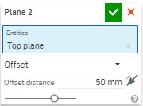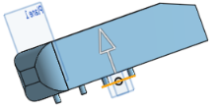

Figure 2.8: Creating a new plane by offsetting "Top" plane.

1. Use the “Split” tool () with the main Ahmed body selected as the “Parts or surfaces to split” and the plane in step 6 as the “Entity to split with”. Click ok () to split the legs from the main body.

## Creating STL files for Meshing

Please export the STL files according to the table 2.2 below. Make sure that all for legs (supports) of the Ahmed body are exported as a single STL file. Appendix B shows figures along with filenames for further clarification.

Table 2.2: Parts to export

|  |  |
| --- | --- |
| File Name | Part |
| ab1.stl | Main rear part of the Ahmed body |
| ab2.stl | Filleted front part of the Ahmed body |
| support.stl | Legs of the Ahmed body |
| ahmed_body.stl | Combined Ahmed body |
| ref_zone1.stl | The reference extrude made in section 2.1.2. |
|  | |
| Format: | STL |
| STL Format: | Binary |
| Units: | Metre |
| Resolution: | Fine |
| Options: | Download |

## Creating refinement areas from ParaView (paraFoam)

This is an alternative method to selecting/generating refinement zones. It can be useful when you would want to keep the “refinement” angle in 3.2.1 but/or manually insert features uncaptured. In this particular case, the starting edge of the slanted back is not picked up by the “includeAngle” set in section 3.2.1. This can be manually added as shown below and the mesh could later be refined in this region.

1. Open ParaView by typing “paraFoam” in a terminal window. Since you are not opening it from a specific OpenFOAM directory, you will be presented with several warnings and a prompt “Would you like to open ParaView anyway <Y | n>:”

Please type “y” (without quotations) and “Enter” (return) to launch ParaView. You will be presented with a screen as shown in figurer 2.9 below.

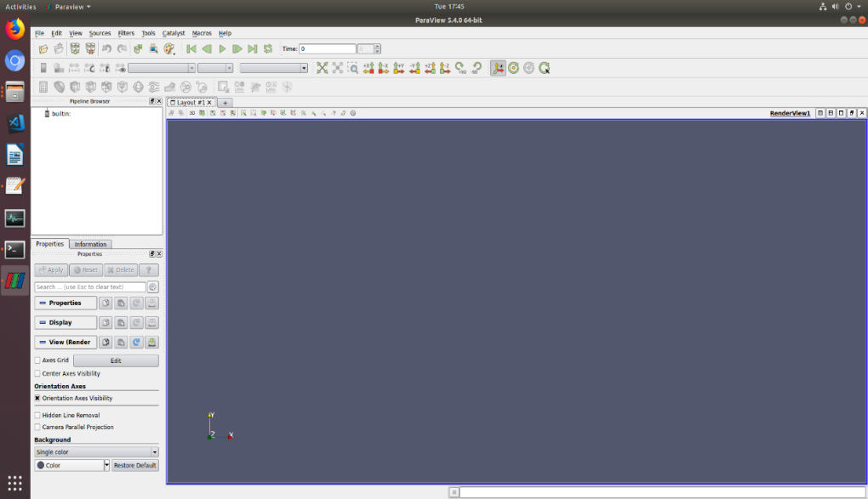

Figure 2.9: ParaView

1. Click “Open” () or go to “File>Open …” and open the ahmed_body.stl” file. Please select “Apply” from the “Properties” tab to display the STL file.

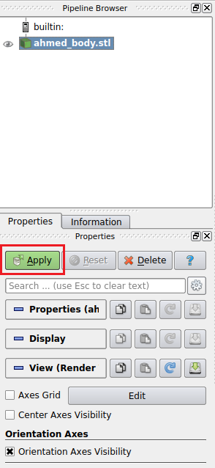

Figure 2.10: Import the ahmed_body.stl file to ParaView.

1. The view can be manipulated with using the mouse and the view controls in the “Camera Controls” toolbar shown in figure 2.11.



Figure 2.11: Camera controls toolbar.

1. To extract edges, click on the “ahmed_body.stl” in the “Pipeline Browser”. Then on the menu bar, go to “Filters>Alphabetical>Feature Edges”. Click “Apply” on the properties window.

This should show some prominent edges of the Ahmed body outlined. The eye next to “ahmed_body.stl” can be used to hide the solid to view the lines only as shown in figure 2.12 below.

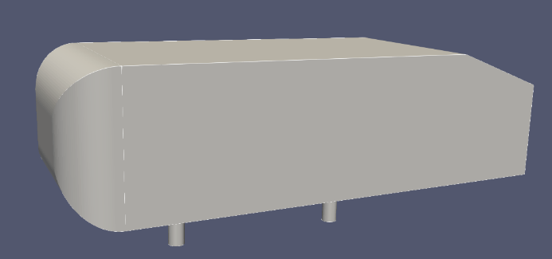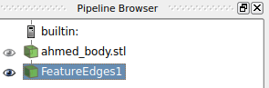

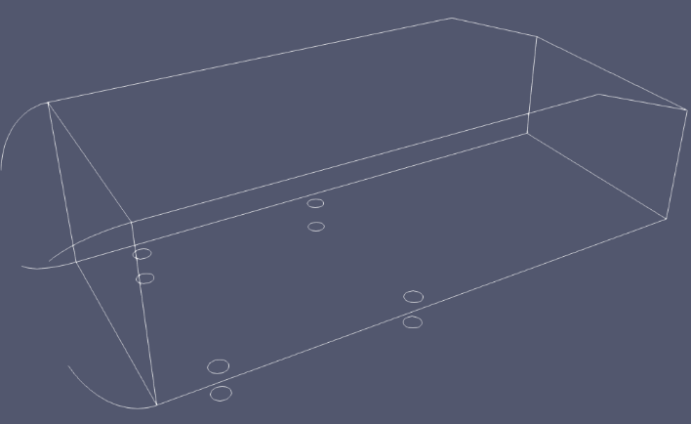

Figure 2.12: Extract feature edges from the Ahmed body.

1. As mentioned in the beginning of the section, the edge at the start of the slanted back is missing. This is due to the “Feature Angle” being set to 30 deg. by default. The feature edges are defined as “edges that are used by two polygons whose dihedral angle is greater than the feature angle.” ( <https://www.paraview.org/Wiki/ParaView/Users_Guide/List_of_filters>)

Since the angle between the two planes around this edge is 20 deg., the “Feature Angle” needs to be less than 20 deg.

1. Replace the default “Feature Angle” by a value lower than 20 (19, 18, 17, ….,2) and click apply to show the missing edge as show in figure 2.13.

Note: Lower the angle value, more feature edges would be captured.

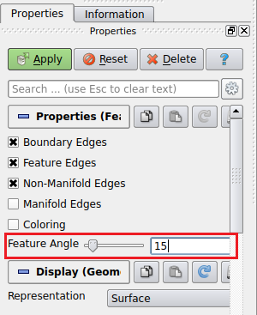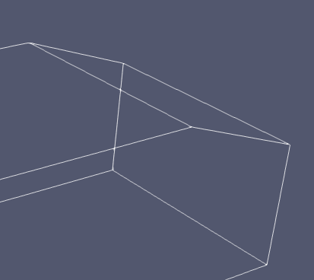

Figure 2.13: Change "Feature Angle" to show edge.

1. Select “Select Cells on (s)” tool () under the “Layout” tab and click on the edge to be extracted.

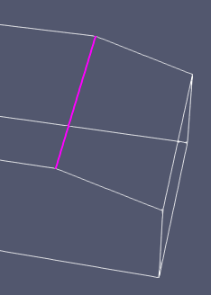

Figure 2.14: Selecting the edge for extraction.

1. Now click the “Extract Selection” under “Data Analysis” toolbar as shown in figure 2.15 and click “Apply” on the “Properties” tab.

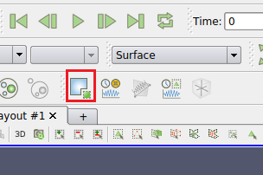c

Figure 2.15: Extracting the edge using the "Extract Selection" tool.

1. Make sure only the extract selection (“ExtractSelection1” in this case) is selected and visible on the “Pipeline Browser”. Click on “Save” () or from menu, select “File>Save Data …”.
2. Select the “Legacy VTK Files(*.vtk)” from the “Files of type” dropdown and name it “edge1”. Save it with rest of the STL files of this tutorial.

Note: Please make sure “Ascii” is selected as the “File Type” in the following window.

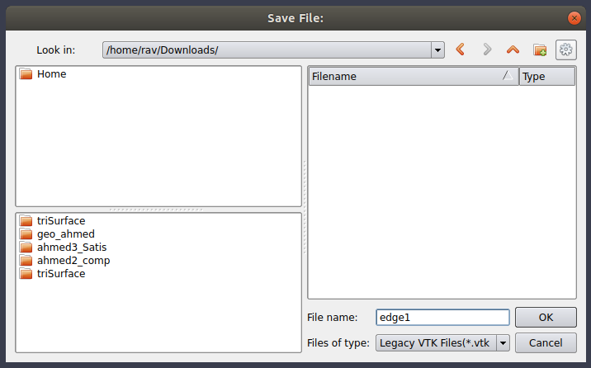

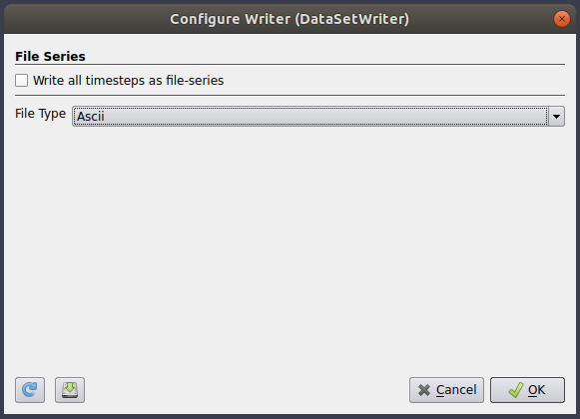

Figure 2.16: Save edge as a .vtk file.

### Making the VTK File Compatible with “surfaceFeatureConvert”

The “surfaceFeatureConvert” command will be used to convert the VTK file to OpenFOAM’s eMesh format. The VTK file generated in section 2.4 may contain additional data (such as Metadata) which will output errors when converting. The following modifications to the VTK file would enable smooth conversion;

1. Open the VTK file generated in section 2.4 in the text editor.
2. Remove the line containing “METADATA” to “DATA” (highlighted in figure 2.17 below) and save it.

Note: Do NOT change any formats or other fields such as co-ordinates, etc.

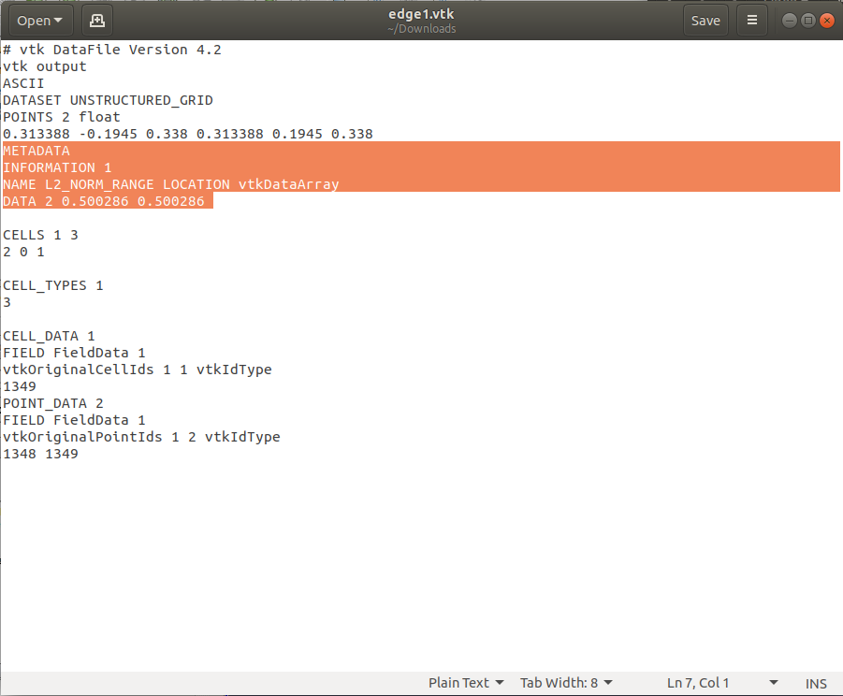

Figure 2.17: Removing additional information from the VTK file.

# OpenFOAM Initial Case Setup

OpenFOAM cases follow a certain file structure and a set of instruction files (dictionaries) to run cases. A standard OpenFOAM case consist of the file structure shown in table 3.1 below.

Table 3.1: OpenFOAM case folder structure.

|  |  |  |
| --- | --- | --- |
|  | Folder | Description |
| Case | Main case directory |
| 0_orgs | Initial data of fields such as velocity, pressure and boundary conditions used to define the problem. |
| Constant | Contains the physical properties and geometries for the case. Also contains the mesh when generated. |
| polyMesh | Contains the mesh after it is generated. |
| triSurface | Contains the geometries (STLs, VTKs, eMesh, etc.) |
| system | Contains dictionaries used to control and run the case (such as blockMesh, controlDict, snappyHexMeshDict, surfaceFeatureExtractDict, meshQualityDict, etc.) |

As the case progresses, additional files (such as time directories, decomposed directories for parallel processing, etc. will be added).

When preparing a case for OpenFOAM, it is advisable to copy a similar tutorial case and edit the dictionaries to suite your case. In this particular case, the “motorBike” tutorial can be used as it is an incompressible, steady state case using the simpleFoam solver.

## Copying Tutorial Cases and Preparing

In your PC, the “run” directory which OpenFOAM cases are run from can be accessed via terminal from “$FOAM_RUN” from anywhere. You do not need to type the full path. Similarly, “FOAM_TUTORIAS” points to original tutorials storage directory.

1. Check if the $FOAM_RUN directory exist;

|  |
| --- |
| ls $FOAM_RUN |

Tip: Use “ls” command to list files and directories within and folder.

If the directory does not exist, create one by;

|  |
| --- |
| mkdir -p $FOAM_RUN |

1. Change to the $FOAM_RUN directory;

|  |
| --- |
| cd $FOAM_RUN |

Tip: Typing “$HOME” would navigate you back to the home folder and “cd ..” would navigate you back one folder.

1. Copy the “motorBike” tutorial to your working (run) directory;

|  |
| --- |
| cp -r $FOAM_TUTORIALS/incompressible/simpleFoam/motorBike . |

Note: The commands, files and folder names are case sensitive.

Tip: Pressing the TAB key after partially typing enough letters of a command/filename would auto-complete it.

Tip: The “-r” ensures all directories and their subdirectories are copied and the “.” after refers it to copy to the current directory.

1. Rename the copied case by;

|  |
| --- |
| mv motorBike $FOAM_RUN/ahmed |

1. Navigate to the copied case directory by;

|  |
| --- |
| cd ahmed |

1. Clean the directory and delete the unnecessary files/folders;

|  |
| --- |
| foamCleanTutorials  foamCleanPolyMesh  rm Allclean Allrun  rm –r 0/include  rm system/streamLines  rm system/cuttingPlane  rm system/forceCoeff |

1. Rename the U.orig file to U;

|  |
| --- |
| mv 0/U.orig 0/U |

1. Delete files in “constant/triSurface” folder and Copy the geometries (STL files and VTK file) generated in previous steps via GUI (drag and drop) or CLI (using “cp” command).

A copy of the prepared case can be found in GitHub under “start”.

## Modifying Dictionaries

OpenFOAM dictionaries contain instructions to run cases. The following sections would show how to adapt the “motorBike” case scripts to the “ahmed” case. This section would only concentrate on “surfaceFeatureExtractDict”, “blockMesh”, “snappyHexMeshDict” and “meshQuality” as these govern the mesh generation.

These dictionaries follow a general C++ format with // marking comment lines and /* and */ marking start and end of multiple line comments. The files contain headers, information sections and indentations, which are not mandatory but good programming practices. Furthermore, it would make it easier to debug and for others to understand your code. Figure 3.1 below shows a typical dictionary header. More about dictionaries can be found on <https://cfd.direct/openfoam/user-guide/v6-basic-file-format/>.

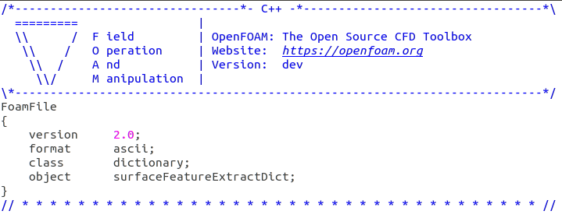

Figure 3.1: OpenFOAM dictionary header.

### surfaceFeaturesDict / surfaceFeatureExtract (surfaceFeaturesExtractDict)

This dictionary provides parameters for the surface features and their extraction. It is located under “<case>/system” directory.

1. Please rename the “surfaceFeaturesDict” file to “surfaceFeatureExtractDict”
2. Open the file and next to “object” replace “surfaceFeaturesDict” with “surfaceFeatureExtractDict”.

Note: Steps 1 and 2 are not mandatory but good practice as the dictionary would be extracting features.

1. Delete the contents below contents between the two //************// lines (highlighted in figure 3.2), henceforth refered to as the body.

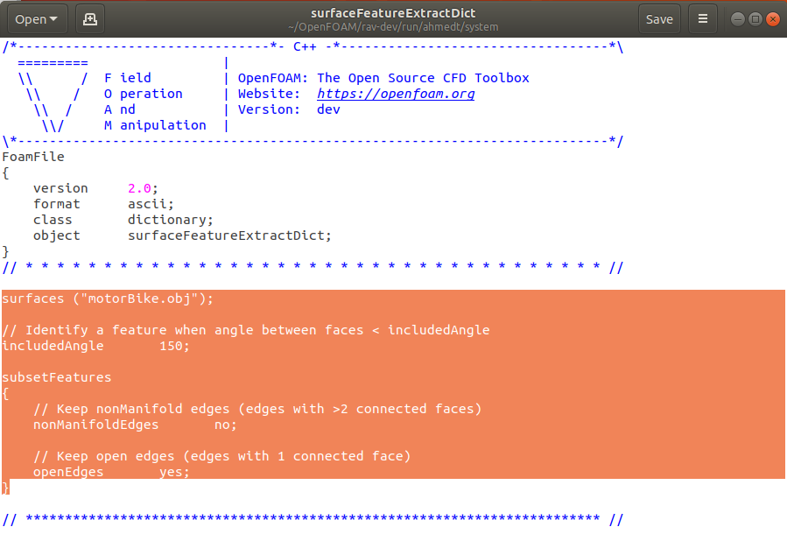

Figure 3.2: Delete the contents of the body (highlighted).

1. Add the following lines to the body which instruct to extract using the “extractFromSurface” method with includeAngle and to write the extraction as an .obj file. A copy of the changed dictionary can be found in GitHub under “dictionaries”

|  |
| --- |
| ab1.stl  {  extractionMethod extractFromSurface;  extractFromSurfaceCoeffs  {  includedAngle 150;  }  writeObj yes;  } |

Repeat the above code for ab2.stl and support.stl in lines below.

1. Save file (“Ctrl+s” or click save) and exit.

### blockMesh (blockMeshDict)

This dictionary governs the parameters for blockMesh tool supplied with OpenFOAM which generates (as the name suggests) a mesh with blocks. This section will look at the generation of a block mesh for the background mesh of the Ahmed body case. More information about blockMesh can be found in <https://cfd.direct/openfoam/user-guide/v6-blockmesh/>.

Please insert the following code to your “blockMeshDict” dictionary below the header. The lines marked with “//” are comments and do not serve any other functions. A copy of the changed dictionary can be found in GitHub under “dictionaries”

|  |
| --- |
| // Factor for scaling  convertToMeters 1;  // Declaring variables using macro syntax notation which can later //be used with $variablename  xmin -3;  xmax 5;  // Try to create ymin, ymax, zmin, zmax  // Cell spacing  deltax 0.1;  deltay 0.1;  deltaz 0.1;  // Calculate the length by using the above variables and assign to //new variables  lx #calc "($xmax) - ($xmin)";  // Try to calc ly and lz    // Calculate the number of cells with above criteria and round  xcells #calc "round($lx/$deltax)";  // Try to calc ycells and zcells  // The 8 vertex co-ordinates of the 3D block (geometry) starting //from 0 vertex number  // Check Appendix C in Tutorial 2 for a visual representation of //vertices  vertices  (  ($xmin $ymin $zmin) // 0 vertex  ($xmax $ymin $zmin) // 1st vertex  ($xmax $ymax $zmin) // 2nd vertex  ($xmin $ymax $zmin) // 3rd vertex  ($xmin $ymin $zmax) // 4th vertex  // Try to create vertex 5-7  );  // Defines the block topology  blocks  (  // Hexahedral (hex) block with vertices in sequential order, number // of cells in each direction  // ($xcells, etc.) and stretching (simpleGrading) of the mesh (in // this case uniform)  hex (0 1 2 3 4 5 6 7) ($xcells $ycells $zcells) simpleGrading (1 1 1)  );  // To be used to define edges joining vertices that are not  // straight. It is assumed straight by default (leave blank)  edges  (  );  // Define the patches for boundary conditions  boundary  (  side2 // patch name  {  type symmetry; // patch type (refer to Tutorial 2  //blockMesh sections for details  faces  (  (3 7 6 2) // list of vertices of the surface patch (face)  );  }  inlet  {  type patch;  faces  (  (0 4 7 3)  );  }  outlet  {  type patch;  faces  (  (2 6 5 1)  );  }  side1  {  type symmetry;  faces  (  (0 1 5 4)  );  }  top  {  type symmetry;  faces  (  (4 5 6 7)  );  }  ground  {  type patch;  faces  (  (0 3 2 1)  );  }  );  // Incase of multiple blocks() (defined earlier), patches to merge  mergePatchPairs  (  ); |

The patches in the blockMeshDict files refers areas of the boundary surface. Some available patches and their descriptions can be found in <https://cfd.direct/openfoam/user-guide/v6-boundaries/#x24-1740005.2.1>. The table 3.2 below gives the patch descriptions used in this tutorial.

Table 3.2: Patch types used in this tutorial <reference>.

|  |  |
| --- | --- |
| Patch | Description |
| wall | Generic type containing no geometric or topological information about the mesh, e.g. used for an inlet or an outlet. |
| symmetry | For patch that coincides with a solid wall, required for some physical modelling. |
| patch | For any (non-planar) patch that uses the symmetry plane (slip) condition. |

### snappyHexMeshDict

This dictionary controls the generation of 3D meshes consisting of hexahedral and split-hexahedral cells from tri-surfaces, STLs or Wavefront Object (.obj) format. Due to the length of this dictionary, it has not been included in the tutorial handout. It can be viewed in the case folder under “system” or in GitHub under “dictionaries”. Comments (following “//”) have been added to explain each parameter.

#### The Four Parts of snappyHexMeshDict

A typical snappyHexMeshDict file consist of 4 main parts, namely castellatedMesh, snapControls (snap), addLayers and Advanced parameters (such as meshQualityControls and writeFlags).

The “castellatedMesh” refines the background mesh close to the features and surfaces which enables easy snapping (figure 3.3). The sizes defined in here are relative to the background mesh (in this case, blockMesh created in section 3.2.2).

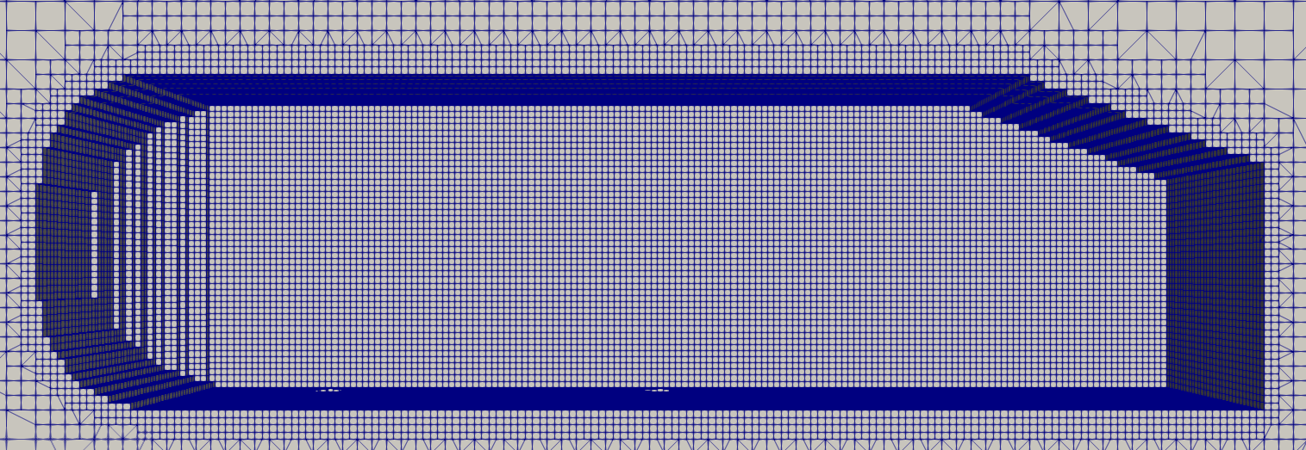 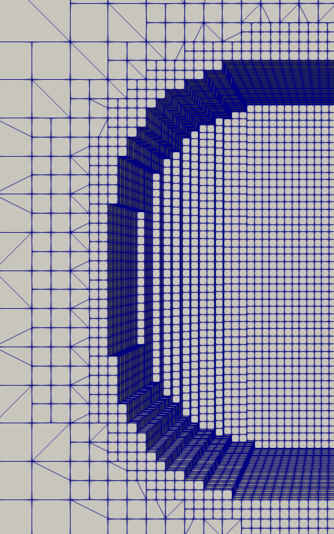

Figure 3.3: Castellated mesh

The “snap” (snapControls/snapping) attempts fit the mesh onto the input geometry (figure 3.4). This is an iterative process and if attempts fail to meet defined mesh quality, it would be re-attempted using reformed parameters.

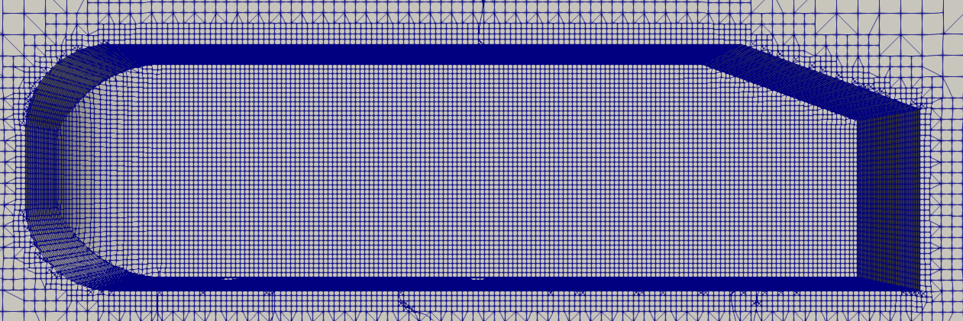 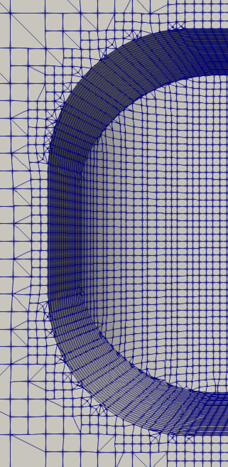

Figure 3.4: Snapping phase.

The “addLayers” (addLayersControls), as the name suggests, adds layers to the defined surfaces (figure 3.5). These fill any voids and irregularities created by shrinking the mesh near surfaces.

|  |  |
| --- | --- |
| *Figure 3.5a: Side view before layers* | *Figure 3.5b: Side view with layers* |
| *Figure 3.5c: Side view before layers (zoomed in)* | *Figure 3.5d: Side view with layers (zoomed in)* |
| *Figure 3.5e: Support (bottom view) before layers* | *Figure 3.5f: Support (bottom view) with layers* |

Figure 3.5: Adding layers to mesh

The first few lines of the “snappyHexMeshDict” indicates which phase of meshing to run. These can be enabled or disabled by setting them to “true” or “false” respectively. These phases can be run together, individually or re-run after corrections. The output can be viewed in stages in ParaView as shown in figure 3.5 by following instructions in section 3.3.

The Advances parameters contain parameters such as “meshQualityControls” (see section x), “writeFlags” (information for post processing), debug flags amongst others.

The table 3.3 below will outline only the fields changed from the “motoBike” case “snappyHexMeshDict” file.

Table 3.3: Changes to "snappyHexMeshDict" dictionary.

|  |  |  |
| --- | --- | --- |
| Parameter | Value | Description |
| geometry | Custom STLs | STL Files for meshing. |
| Primitive geometry | “refinement_box” (commented out for now, not needed) | Simple Geometry created within OpenFOAM to assign refinement zones. |
| castellatedMesh |  |  |
| nCellsBetweenLevels | 2 (default is 3) | Number of buffer layers of cells when transitioning through levels of refinement |
| features | eMesh files generated by  “surfaceFeatureExtract” | Feature edge refinement |
| level | 0, 4 | Level of refinement (see Appendix E for levels of refinement) |
| refinementSurfaces |  | Surface refinement of custom STLs name in “geometry” section. |
| level | (2 2), (4 4) | Level of refinement, min and max for cells intersecting the surface. |
| resolveFeatureAngles | 30 | Angle above which max refinement is added. |
| planarAngle | 30 | Angle used to detect opposite surfaces. |
| Region-wise Refinement | Regions from Custom STLs (names assigned in “geometry” used) | Regions for refinement with level (x y) where x is distance, y is level of refinement from surface to distance x. |
| LocationinMesh | (2 0 1) | Location (co-ordinates) inside the enclosure to be meshed. This must not lie/intersect the body. |
| snapControls |  |  |
| nSolverIter | 300 | Number of mesh displacement relaxation iterations. Higher values result in better fitted mesh but will take more time. |
| nFeatureSnapIter | 20 | Iterations for feature edge snapping. Increase for better feature edge quality. |
| addLayersControls |  |  |
| nSurfaceLayers | 3 | Number of layers |
| expansionRatio | 1.2 | Factor to increasing from layer to layer. |
| finalLayerThickness | 0.8 | Thickness of the layer furthest from the wall. |
| minThickness | 0.001 | Minimum thickness of layers (relative or absolute) |
| featureAngle | 330 | Angles above which mesh is collapsed. |
| nRelaxIter (slipfeature) | 10 | Max. number of snapping relaxation iterations. Improves the quality of the body fitted mesh. |
| nSmoothNormals | 1 | Number of smoothing iterations of interior mesh movement direction. |
| //Advanced |  |  |
| meshQualityControls | Quality parameters for the mesh | Can be in a different file with #include notation |
| relaxed | maxNonOrtho 75; | Max non-orthogonality allowed. |
| nsmoothscale | 4 | Number of error distribution iterations. |
| errorReduction | 0.75 | Scale back mesh displacement at error points. |

The mesh quality file can be put in a separate meshQualityDict file and the “#includ “meshQualityDict”” can be used.

### meshQuality (meshQualityDict)

This dictionary defines parameters to ensure the quality of the mesh generated is satisfactory. If the mesh does not comply with the requirements of this dictionary, it would be re-iterated with additional (defined) settings.

In this particular case, the following parameters in table 3.4 have been changed. The rest are included from the default “meshQualityDict” supplied with OpenFOAM by the line “#includeEtc “caseDicts/mesh/generation/meshQualityDict”. A copy of the changed dictionary can be found in GitHub under “dictionaries”

Table 3.4: Changes to "meshQualityDict" dictionary.

|  |  |  |
| --- | --- | --- |
| Parameter | Value | Description |
| maxNonOrtho | 75 | Max non-orthogonality allowed. |
| maxBoundarySkewness | 4 | Maximum boundary face skewness allowed |
| minFaceWeight | 0.02 | Minimum face interpolation weight |

### decomposePar (decomposeParDict)

OpenFOAM cases can be processor intensive. These are by default, run on one core of the processor. The “decomposeParDict” allows to specify the number of cores to use and method to split (decompose) the case. More on “decomposePar” can be read on <https://cfd.direct/openfoam/user-guide/v6-running-applications-parallel/>. The table 3.5 below shows the parameters needed for this case, rest (in dictionary body) can be deleted. A copy of the changed dictionary can be found in GitHub under “dictionaries”

Table 3.5: Changes to "decomposeParDict" dictionary.

|  |  |  |
| --- | --- | --- |
| Parameter | Value | Description |
| numberOfSubdomains | 4 | Number of processors (cores) to use. |
| method | scotch | Method used to decompose case. |

## Mesh Generation

This section will look at generating a mesh that conforms to the parameters set out in the above sections. This would be done via CLI in a terminal window. The generation process for this case can be seen in figure 3.6 below.

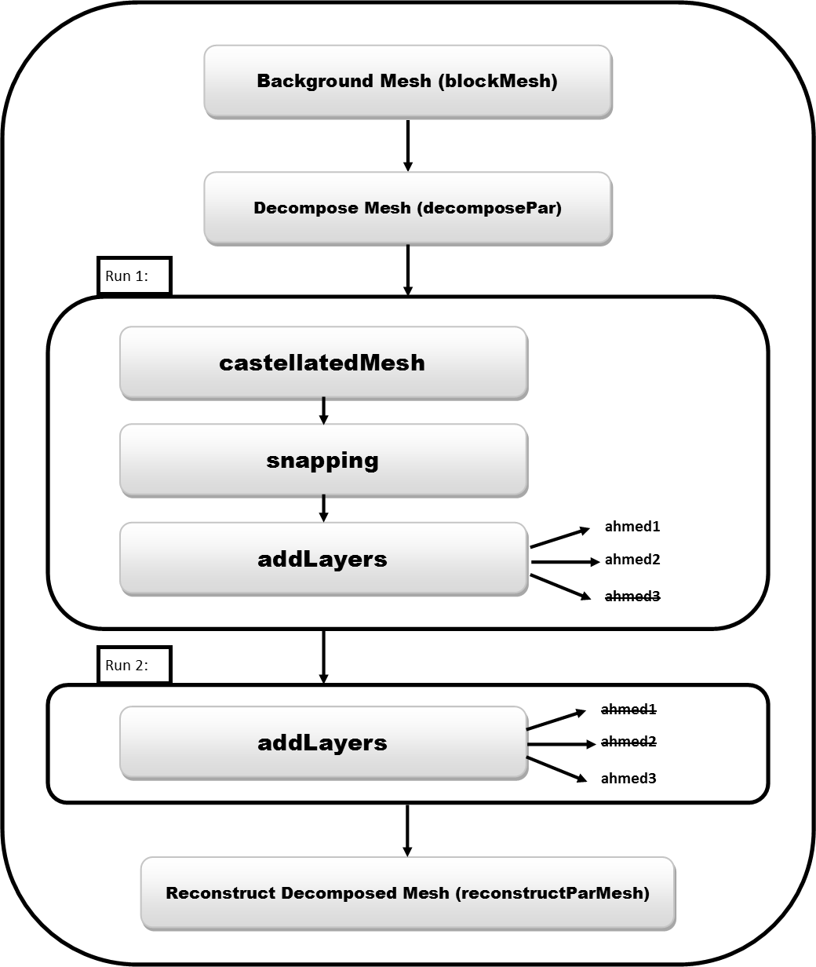

Figure 3.6: Meshing process for this case.

It should be noted that an extra “addLayers” step is run (“Run 2” in figure 3.6) due to the mesh collapsing (Appendix D) if meshed in a single run. This is due to the overlapping of layers from the main Ahmed body and the supports.

Follow the below commands (also located in the “ReadMe” file in the “case” folder) to generate the mesh. You can highlight the command(s) and click the middle mouse button to copy. It can then be pastes on the terminal by clicking the middle mouse button again.

Note: The lines following “#” are not executed. Similar to “//” in OpenFOAM, these are excluded as comments.

Run 1: Generating the mesh without layers for supports

|  |
| --- |
| # Clean the case directory  foamCleanTutorials  foamCleanPolyMesh  # Convert edge1.vtk to eMesh format  surfaceFeatureConvert constant/triSurface/edge1.vtk constant/triSurface/edge1.eMesh  # Extract surface features  surfaceFeatureExtract -dict system/surfaceFeatureExtractDict  # Generating the background mesh  blockMesh  # Decompose case for parallel run  decomposePar  # Mesh using snappyHexMesh in parallel  mpirun -np 3 snappyHexMesh -parallel -dict system/snappyHexMeshDict |

Run 2: Adding layers to support

1. Open “snappyHexMeshDict” file and set the following parameters as shown in table 3.6 and save.

Table 3.6: Changes for “Run 2”

|  |  |  |
| --- | --- | --- |
| Parameter | Value | Description |
| castellatedMesh | false | Turn off castellatedMesh (already done in “Run 1”) |
| snap | false | Turn off snapping (already done in “Run 1”) |
| addLayers | true | Needed for adding layers to supports |
| nSurfaceLayers | In ahmed1: 0 | Already done in “Run 1” |
|  | In ahmed2: 0 | Already done in “Run 1” |
|  | In ahmed3: 3 | Add 3 layers |

1. Run the mesh generation command again as shown below.

|  |
| --- |
| # Mesh using snappyHexMesh in parallel  mpirun -np 3 snappyHexMesh -parallel -dict system/snappyHexMeshDict |

## Checking the Generated Mesh

### Using checkMesh Command

To check the quality of the mesh and any errors (skewness, non-orthagonality , etc.), the following command can be run.

|  |
| --- |
| # Check mesh in parallel  mpirun -np 3 checkMesh -parallel |

It would give an output similar to figure 3.7 below. Any deformations (errors, warnings, etc.) would be highlighted by “*” in the beginning of the line. Severe the error, higher the number of “*” in the beginning of the line.

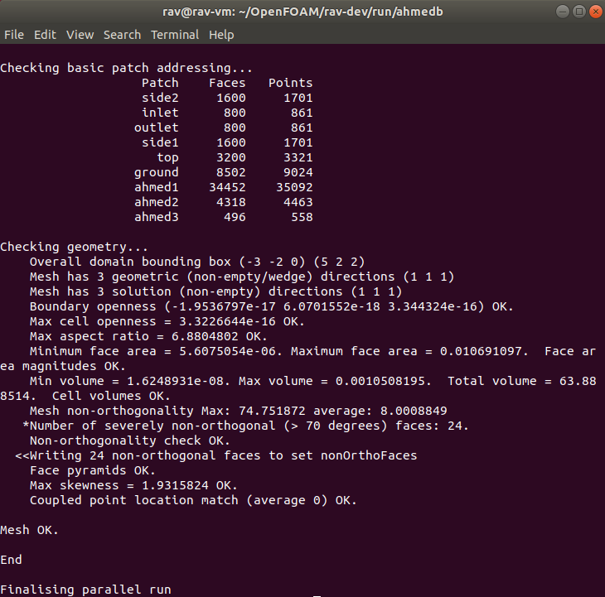

Figure 3.7: Output from "checkMesh".

### Using ParaView

ParaView can be used to check the mesh visually once finished by typing the following code;

|  |
| --- |
| ParaFoam -builtin |

This will launch ParaView with the case ready to be imported as shown in figure 3.8. Please follow the steps below.

|  |  |
| --- | --- |
| Figure 3.8: ParaView with mesh. | 1. From the “Case Type” dropdown, select “Decomposed Case” as the case is in its decomposed state. 2. Make sure the “internalMesh” is selected in the “Mesh Regions” is selected and clock “Apply”.   You will now see a solid block. To view the internal mesh, a “Clip” or “Slice” can be made.   1. Make sure the “<case>.foam” file is selected and click on the “Clip” or “Slice” in the “Common” toolbar (figure 3.9). 2. Select “Y Normal” (to get a cross section from the y-axis) and click “Apply”. 3. Adjust your view by using your mouse or the “Camera Controls” toolbar (figure 2.11).   Tip: You can unselect the “Show Plane” in the clip/slice “Properties” pane to hide it.   1. To view the mesh, change the representation from “Surface” to “Surface with Edges” from the “Representations Toolbar” dropdown (figure 3.10). |



Figure 3.9: "Clip" in "Common" toolbar.

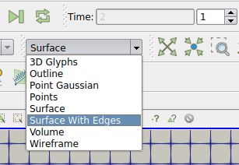

Figure 3.10: Representations toolbar.

You should now see the first step of the meshing process (castellatedMesh). You can check the rest of the mesh by navigating the steps in “VCR Controls” and “Current Time Controls” (figurer 3.11). You can obtain different views and sections of you mesh and check if it is similar to figure 3.5 as well.



Figure 3.11: "VCR Controls" and "Current Time Controls".

To check the thickness of the layers on the Ahmed body as shown in the Appendix D comparison as follows;

1. Hide the different view/sections created from the pipeline browser by clicking the “eye” next to them.
2. Make the “<case>.foam” file visible and select the geometry (“ahmed1”, “ahmed2” and “ahmed3” as named in section 3.2.3) and unselect the “internalMesh” then click “Apply”. You should now be able to see the Ahmed body.
3. Select the “thickness” from “Active Variables Toolbar” and this should colour the surface of the Ahmed body with the thickness (as shown in Appendix D).

Tip: You can enable the internal mesh, and create different views/sections to see the layer sizing with the colours.

Tip: You can switch back to “Surface” from “Surface with Edges” in the “Representations Toolbar”.

Note: You will have to go through different time steps as this mesh is in its decomposed stage. Eg: Last step (4) only shows the layers of the support, not the rest of the body as this was the last “addLayers” step.

## Recompiling the Mesh

As mentioned in section 3.4, the mesh is still in its decomposed stage. To reconstruct the completed mesh, use the following command;

|  |
| --- |
| reconstructParMesh |

This will compile the mesh with numerical (1, 2, 3, 4) folders appearing on the case file directory. Each folder corresponds to the different stages (as seen in ParaView in section 3.4) but with the complete mesh up to that step. Therefore, the last folder (“4” in this case) contains the completed mesh.

# Appendix A: Co-Ordinates from Onshape

Co-ordinates of points (vertices) can be easily obtained from Onshape by clicking on the point/vertex and looking at the bottom left corner of the screen.

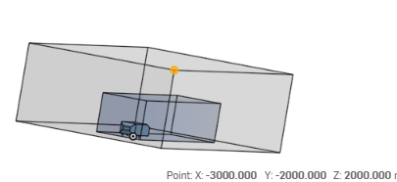

# Appendix B: STL Exports

|  |  |  |
| --- | --- | --- |
| ab1.stl | | ab2.stl |
| support.stl | ahmed_body.stl | |
| ref_zone1.stl | | |

# Appendix C: Vertices of a the Geometry

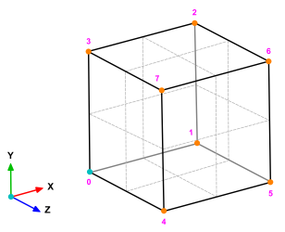

# Appendix D: Single Run vs 2 Runs (snappyHexMesh)

Single run:

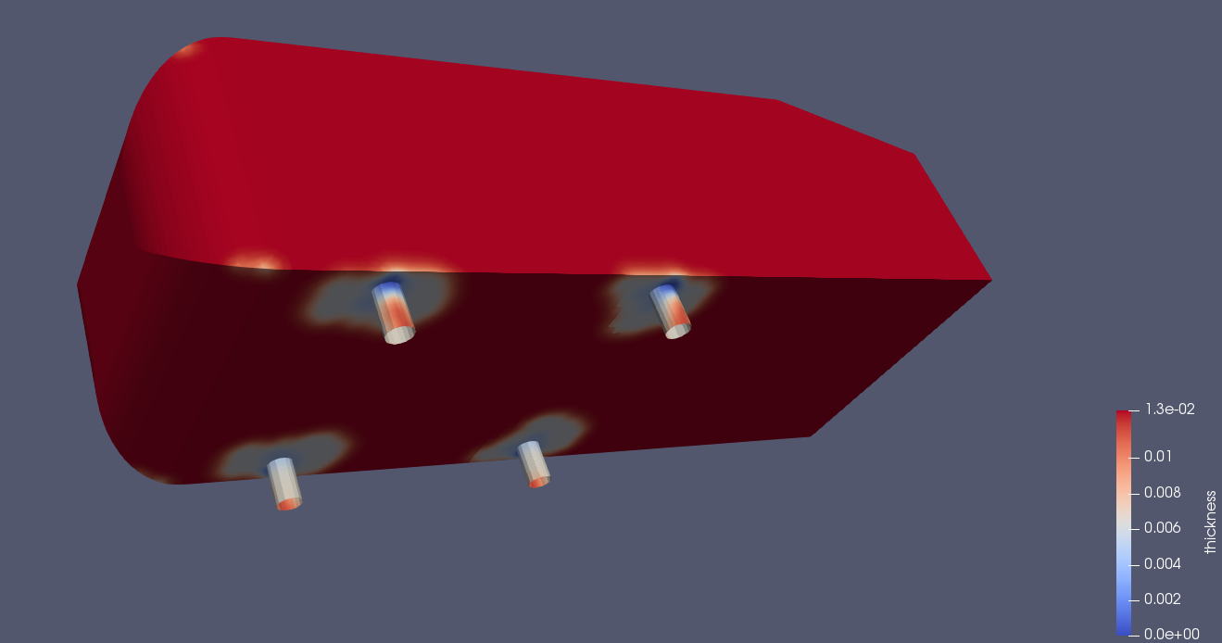

Two runs (separate “addLayers” for supports):

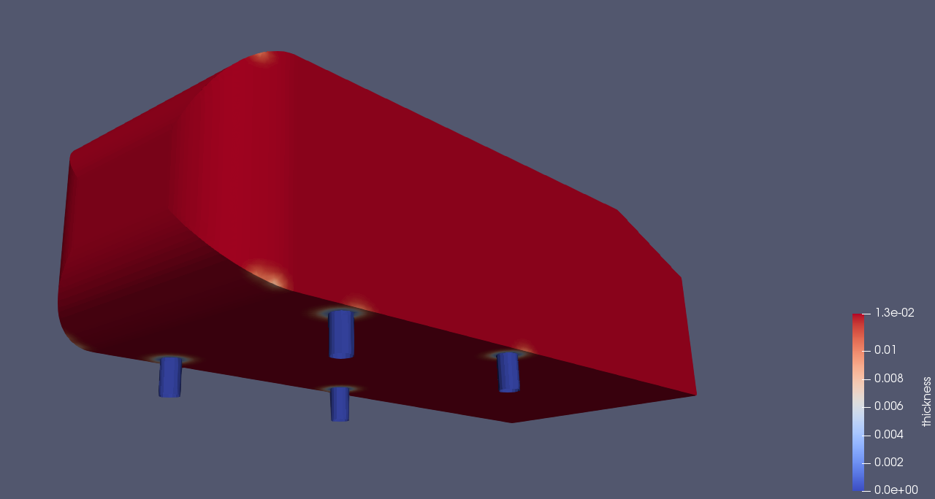

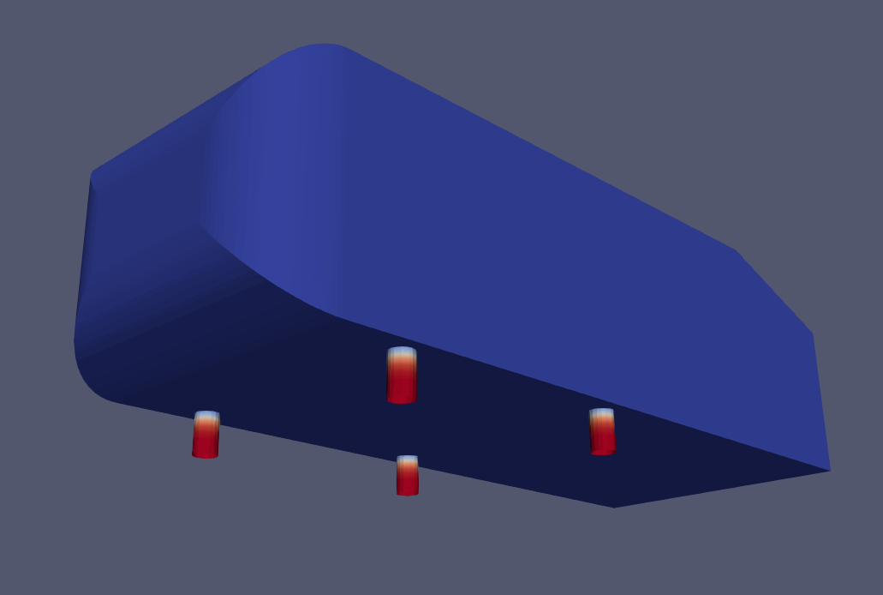

Note: The images are in 2 different steps (stages) due to layers for supports being applied after meshing of the main body is complete.

# Appendix E: Refinement Levels

Refinement level is the splitting of a hexahedron into different smaller parts. This is illustrated in the figure below.

